MEDIA RELEASE
The Secret Battle
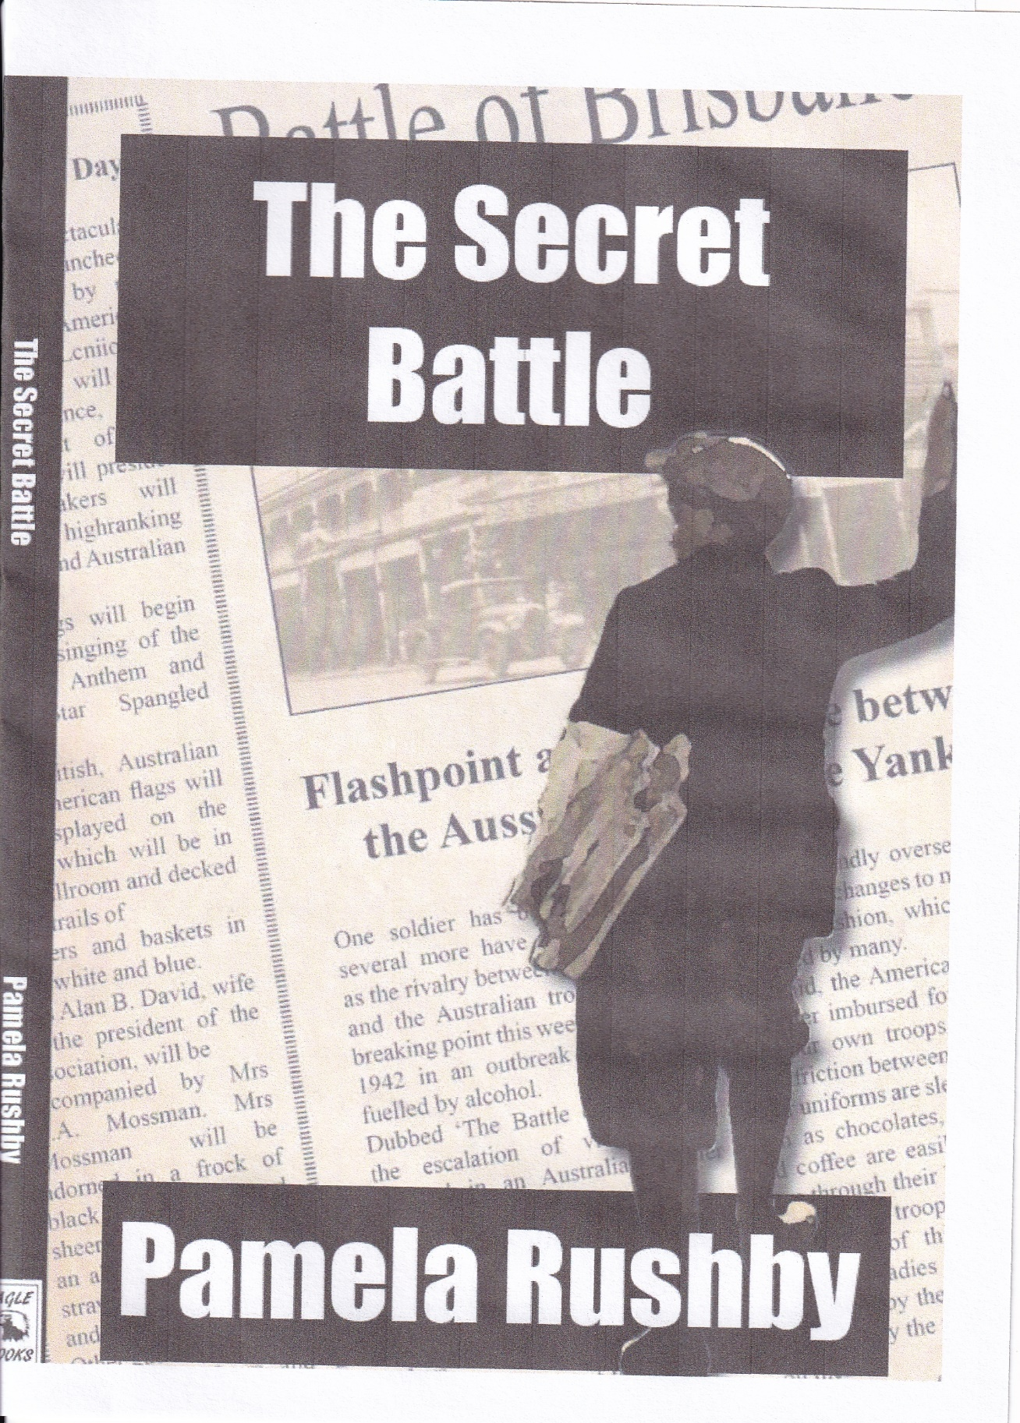

Brisbane 1942. And a secret battle. A battle that the Australian and American governments hushed up. Concealed. Censored.
In 1942, over two days, Australian and American servicemen fought against each other, rioting in the streets of Brisbane, in an incident that became known as the Battle of Brisbane.
When multi-award winning author Pamela Rushby began researching the story of the Battle of Brisbane, she found many more interesting events of World War 2 Brisbane than she’d expected. That newspapers were told not to report the incident, and that news of it never reached America. That spaghetti arrived in Brisbane in a big way, in the legendary Mama Luigi’s. That civilians were panicked when Japanese planes – Zeros – appeared unexpectedly and unannounced, screaming over Brisbane. That many believed that, if the Japanese invaded, Australia would be abandoned to them, above a ‘Brisbane line’.
Nine-year-old Roddy is a newspaper boy in the city, his afterschool job selling evening newspapers, shouting ‘Tellee! City Fiiinal! Getcher Teeelllleee!’ When Roddy becomes caught up in the Battle of Brisbane, and helps an injured American serviceman, he never expects that the battle will become covered up, a wartime secret, never to be reported in the newspapers he sells. Or that his life will be changed forever – all the way to the USA.

A fast-moving historical novel by multi-award winning author Pamela Rushby
Pam would be delighted to talk about the Battle of Brisbane, Mama Luigi’s, the Brisbane Line, Zeros over Brisbane – and the book, of course!
Published by Eagle Books, 2021
For interview or further information: Pamela Rushby
P.Rushby@internode.on.net 0418778058 www.pamelarushby.com

